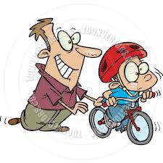
Revision Name: .......................................

Forces & Safety

1 What is a force?
A Something that changes the way an object moves.
B Something that makes you do something you do not
want to do.
C A power that gives you special abilities.
D Something like electricity.

2 What do we mean when we say ‘the forces are unbalanced’?
____________________________________________________________________________________________________________________________________________________________________________________________________________________________________________________________________________________________________________________________________________________________

3 When all the forces acting on a moving object are equal what will the object do?
A Start to move more quickly.
B Continue moving at the same speed.
C Change direction.
D Slow down and come to a halt.

4 What does friction do?
A It makes people angry.
B It causes things that are moving to speed up.
C It helps planes to move easily through the air.
D It opposes movement and causes things to slow down.

5 What is weight and what unit do we measure it in?
_____________________________________________________________________________________________________________________________________________________________________________________________________________________________________________________________________

6 Why do we end up with the skin scraped off our elbows and knees if we fall over on a rough
surface?
____________________________________________________________________________________________________________________________________________________________________________________________________________________________________________________________________________________________________________________________________________________________

7 Explain terminal velocity?
____________________________________________________________________________________________________________________________________________________________________________________________________________________________________________________________________________________________________________________________________________________________

8 When a vehicle we are travelling in turns a corner quickly we feel as if we are being thrown in the
opposite direction. Explain what is really happening.
____________________________________________________________________________________________________________________________________________________________________________________________________________________________________________________________________________________________________________________________________________________________

9 Explain what the four forces a plane experiences are.
____________________________________________________________________________________________________________________________________________________________________________________________________________________________________________________________________________________________________________________________________________________________

10 Do you think making the wearing of seat belts compulsory in cars was a good idea? Explain.

________________________________________________________________________________________________________________________________________________________________________________________________________________________________________________________________________________________________________________________________________________________________________________________________________________________________________________________________________________________________________________________________________________________________________________________________________________________________________________________________________________________________________________________

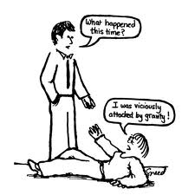
UNSCRAMBLE THESE WORDS
LULP _______________________________________
CRIFNOIT _______________________________________
ECORF _______________________________________
SHUP _______________________________________
VITAGRY _______________________________________
SICHYPS _______________________________________
LABANCED ECORF _______________________________________
TACCONT ECORF _______________________________________
WETNON _______________________________________
GHEWIT _______________________________________
TINERIA _______________________________________
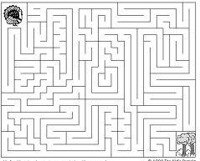
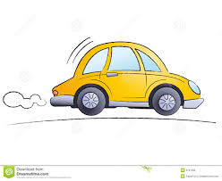
Use the force of your pen to find a path for the CAR to get to THE TREES

